**Variables in Java**

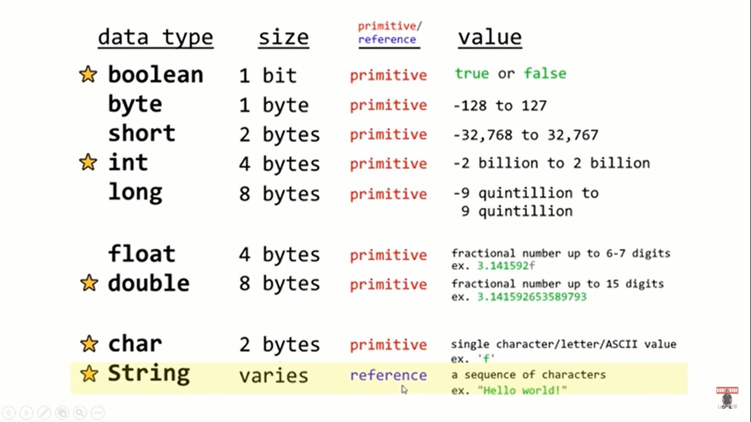  
**Start** indicating some most important data types in Java.

There are **8** **Primitive** data types in Java.   
Out of 8 there is a special **reference** data type called a string.

Size of **boolean** (data type), so it can only hold two values i.e. *true* & *false.*

**float** has less precision than double. There is one strange convention with floats, if we’re going to assing a value to a variable that’s of the float data type, we need to follow the value with the letter f.   
Whereas with the variable of double data type, we don’t need to do so, that’s is one major difference one assigning values between these two.

**Char** (read as Chaar ex: charizard of Pokemon) data type.

In **string** data type, the size really varies because these are reference data types. They store a sequence of chanracters like a word or a sentence. You could store a single character within a string but chars and strings behave differently because of the difference in their data types.  
String data type always begins with a capital letter.

**Difference between Primitive & Reference data Types**

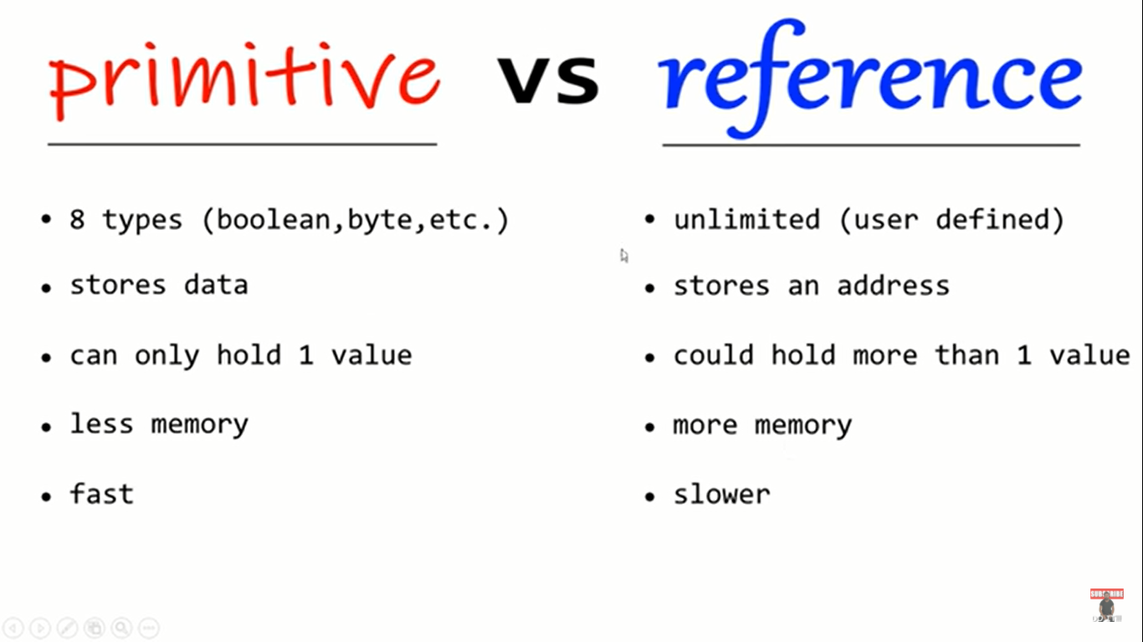

**Note:**

